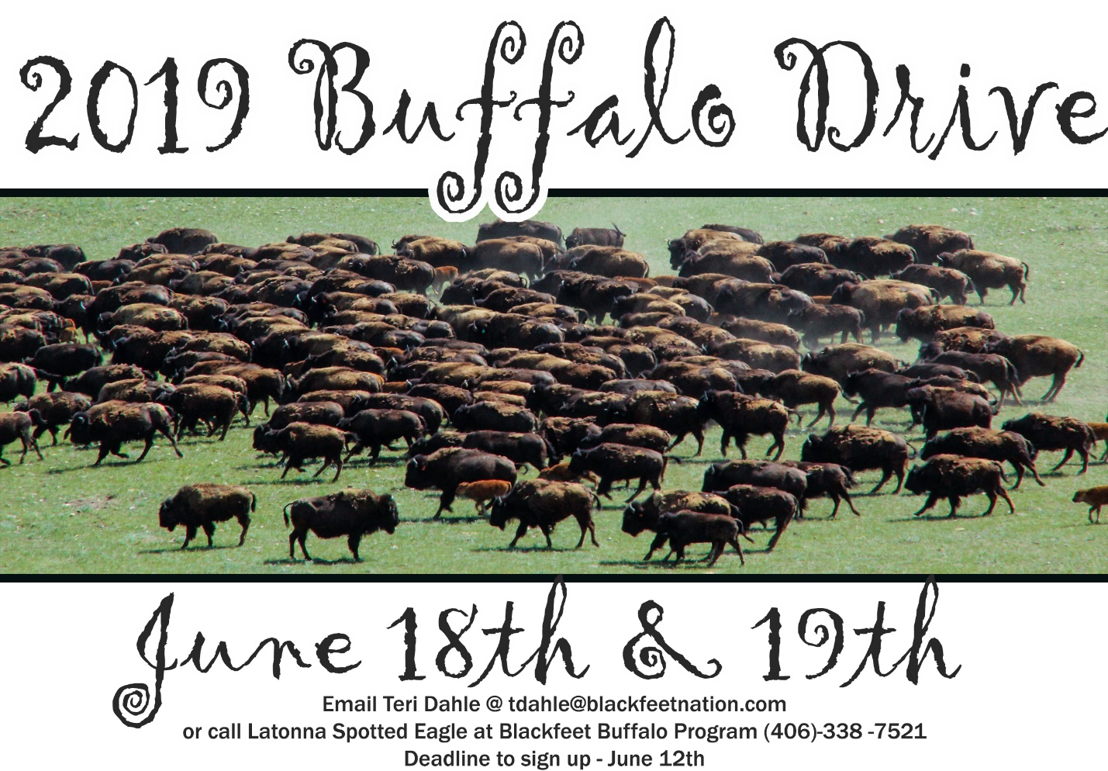
The Blackfeet Buffalo Drive will take place on June 18th and 19th. Anyone that is riding in the buffalo drive must attend a horse riding clinic on June 17th. The cost to ride or side by side in the drive is $500.00 which includes a horse and a guide or a side by side and guide. A meal will be provided after clinic on June 17th and breakfast, lunch and supper on June 18th. On June 19th breakfast and lunch will be provided. If you are interested in being part of this epic event please fill out the form by June 12th. If lodging is needed please inform us and that will be an extra charge if staying in a TP. (You must get your own hotel otherwise.) There will be viewing spots for people to take pictures for those who do not want to ride.
Name________________________________________
Address_________________________________City___________________State__________Zip_______
Phone Number_______________________Email____________________________________

Riding_______ Yes _______________No_______________ Follow along in Side by Side____________________
Have you rode a horse before?________________ Experience level from 1 NONE to 10 VERY Experienced ________

Lodging_______ TP_____________ Hotel________________

Group discounts if there is 2 or more in one group staying in one TP.

